44.54: a) The number of protons in a kilogram is
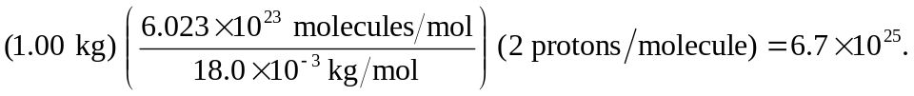
Note that only the protons in the hydrogen atoms are considered as possible sources of proton decay. The energy per decay is 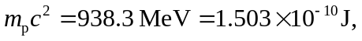 and so the energy deposited in a year, per kilogram, is 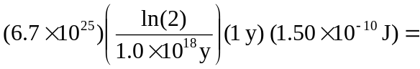
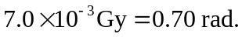
b) For an RBE of unity, the equivalent dose is (1) (0.70 rad) = 0.70 rem.

